# Slicing in Both Directions

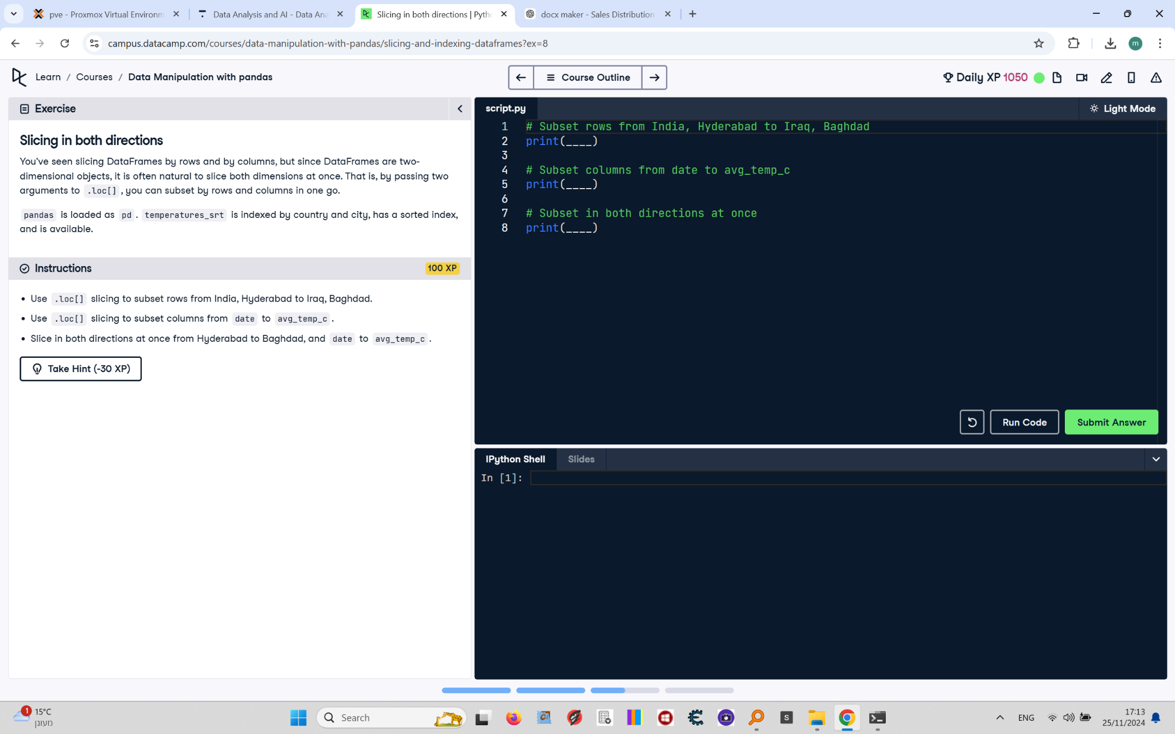

You've seen slicing DataFrames by rows and by columns, but since DataFrames are two-dimensional objects, it is often natural to slice both dimensions at once. That is, by passing two arguments to .loc[], you can subset by rows and columns in one go.  
  
pandas is loaded as pd. temperatures_srt is indexed by country and city, has a sorted index, and is available.

## Final Answer

# Subset rows from India, Hyderabad to Iraq, Baghdad  
print(temperatures_srt.loc[("India", "Hyderabad"):("Iraq", "Baghdad")])  
  
# Subset columns from date to avg_temp_c  
print(temperatures_srt.loc[:, "date":"avg_temp_c"])  
  
# Subset in both directions at once  
print(temperatures_srt.loc[("India", "Hyderabad"):("Iraq", "Baghdad"), "date":"avg_temp_c"])